Explore Your Archive - 7 December 2025
9/9 #EYAYourArchive
Mission to Korea
In 1958, following an invitation from the Bishop of Kwangju in Korea, five Brothers were chosen to set up a mission there: Brothers Timothy Deane, Fergus Skehan, Ephrem Bogues, Bede Greaney, and Brendan Flahive.
There had been a foundation set up in New Jersey to fundraise for the Korea mission by collecting equipment, money and medications. There were already Columban Fathers working there, who helped the Saint John of God Brothers to settle into their new mission work.
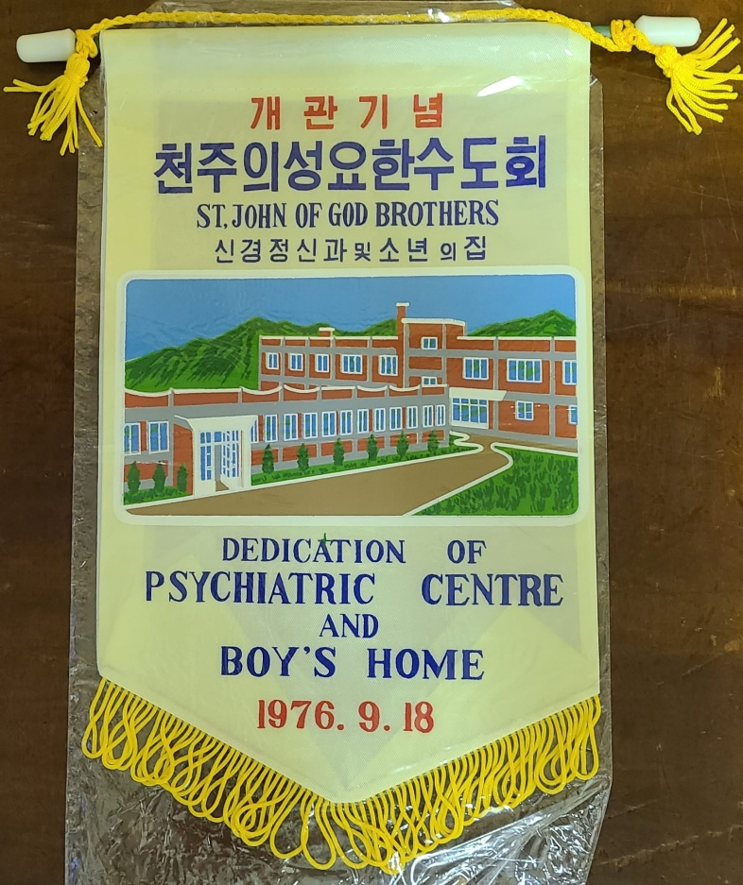
Here you can see a flag commemorating two foundations of the Brothers in Korea: the dedication of the Psychiatric Day Therapy Centre set up in 1976 where patients were attended from 8:30 am until 5 pm, and also the Home for Orphan and Abandoned Boys which was set up in 1975 in response to inadequate care which had been identified in the existing poor house.
As time went on, there were more Korean vocations, leading to Korea becoming a Delegation of the Irish Province, then a Vice-Province in 1998, and then an independent Province in 2005.
Explore Your Archive is an initiative to bring archival documents and their history to the public. For nine days, items are presented, with a different theme used each day, from the archives of the West European Province of the Saint John of God Brothers. Today's theme is anything in ‘your archive’, as shown above.



