Explore Your Archive - 6 December 2025
8/9 #EYAAnniversaries
70 Years of Lucena [Child Guidance] Clinic
There was a need recognised, in the mid-1950s, for children and adolescents to have a centre to go to for professional advice related to mental health difficulties. The Saint John of God Brothers came to provide this service when they bought Dunfillan House in Rathgar, which they opened as a clinic on 1 September 1955. It was so much needed, that in the space of three months the clinic had one hundred new cases, meaning the Brothers had to stop taking new clients for a while.
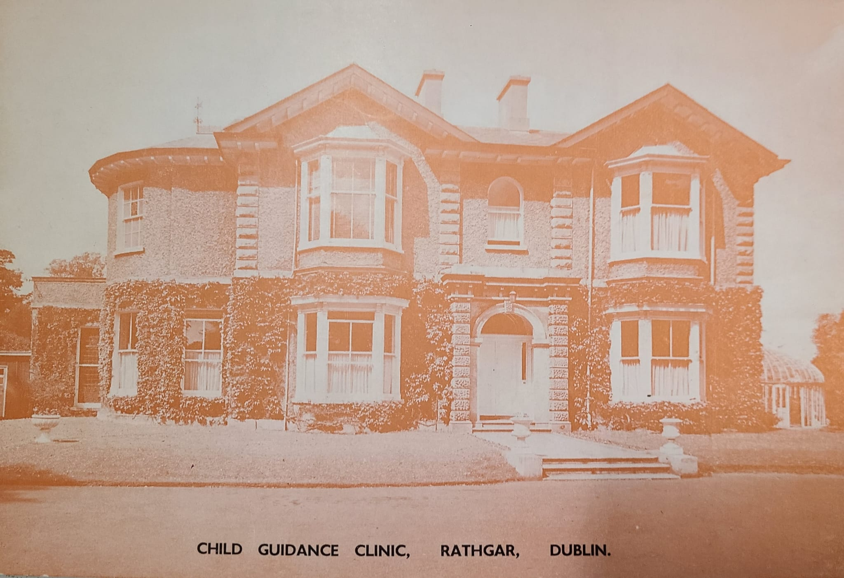
Child Guidance Clinic on cover of booklet, 1970s
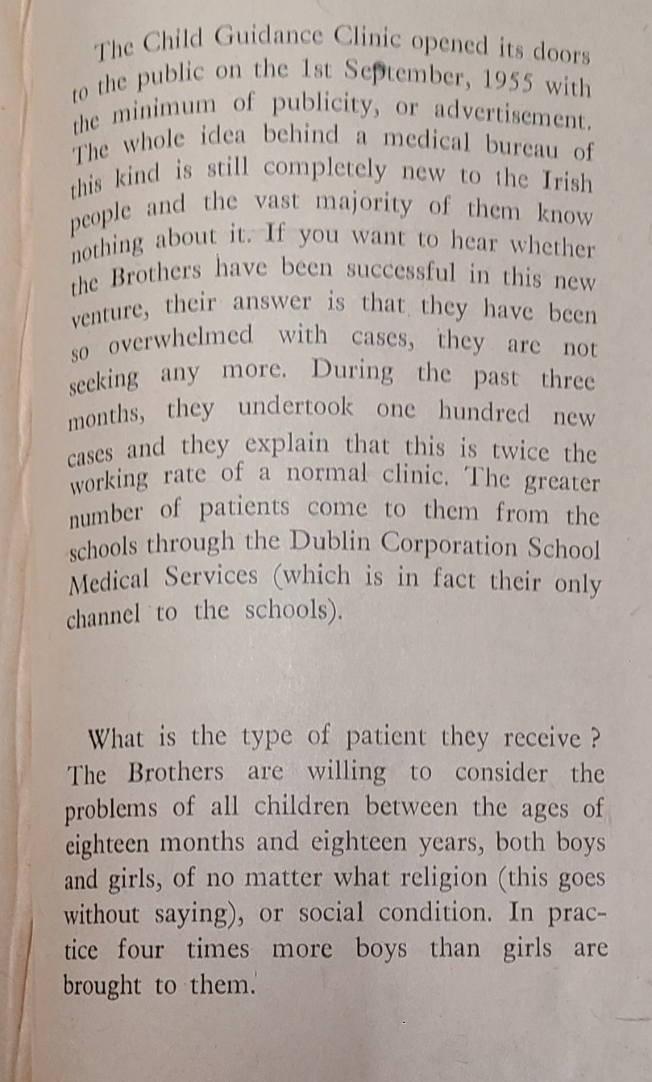
You can see some extracts of an article published in the Order's Caritas magazine about the new clinic soon after it opened. You can also see Dunfillan House above, on the cover of a booklet about the service from the 1970s.
Dunfillan was a private residence which had been built sometime between 1843 and 1865. It is present on the Ordnance Survey map of 1882.
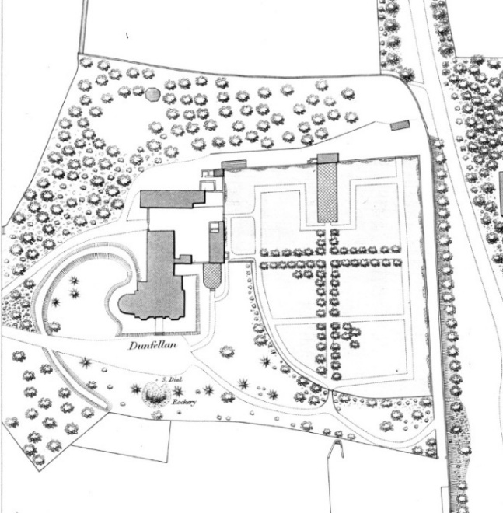Dunfillan on Ordnance Survey Map 1882

The Rathgar clinic was originally called the Child Guidance Clinic, and later renamed Lucena Clinic after Lucena Street in Spain, where Saint John of God set up his first hospital to look after sick people and those with disabilities. This year (2025) celebrates the 70th anniversary of the opening of Lucena Clinic.
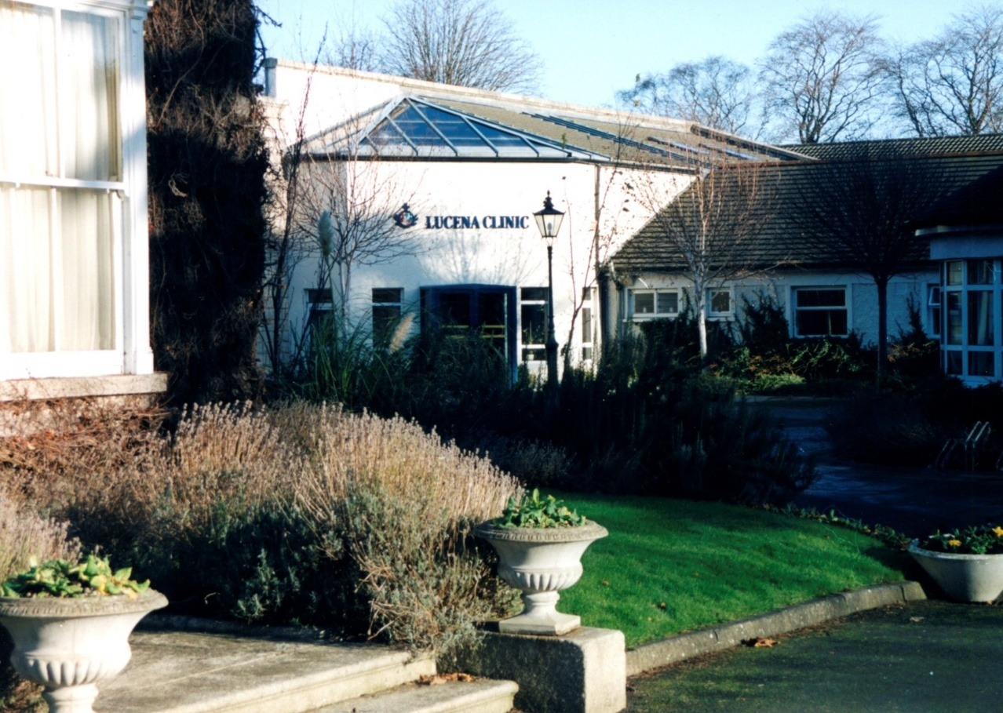
Lucena Clinic 2011
Explore Your Archive is an initiative to bring archival documents and their history to the public. For nine days, items are presented, with a different theme used each day, from the archives of the West European Province of the Saint John of God Brothers. Today's theme is anniversaries, as shown above.

