Explore Your Archive - 5 December 2025
7/9 #EYAInclusion
Shoemaking at Mulhuddart
In 1938, the Saint John of God Brothers opened Hollywoodrath, a country house in Mulhuddart outside Dublin, as a residence for boys suffering from epilepsy. These were the days before anti-epileptic medication, and the institution at Mulhuddart was the first such place in Ireland dedicated to caring for people with seizures. Residents were encouraged to learn how to work in a safe setting where they could be looked after. Quite a few made full or partial recovery, allowing them to return to community or family life after a few years.
Here you can see a photograph of a boy learning the trade of shoemaking. At a time when somebody might easily be excluded from many things in life due to disability, these people experienced inclusion within the Mulhuddart community.
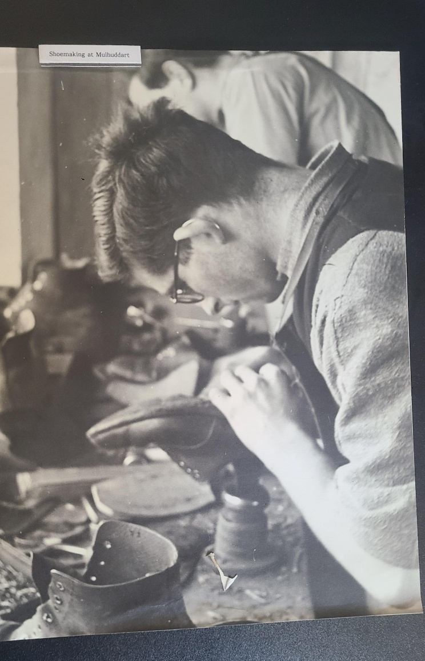
Explore Your Archive is an initiative to bring archival documents and their history to the public. For nine days, items are presented, with a different theme used each day, from the archives of the West European Province of the Saint John of God Brothers. Today's theme is inclusion, as shown above.



