Explore Your Archive - 4 December 2025
6/9 #EYADigital
Preserving Audio Archives
Thinking of archives usually conjures up ideas of paper documents – loose pages, ledgers and notebooks. Yet archive material can take various other forms.
There is a great need to preserve non-textual archives. Some of these archives are already in digital format on computers or in the cloud, and others are analogue (on CDs, DVDs, cassettes) which should be migrated and backed up digitally. One example is oral histories done some decades ago (with great foresight!), which we have on minidiscs, and which are now backed up in digital format to make the content more accessible and durable in today's age. The original discs will naturally also be preserved.
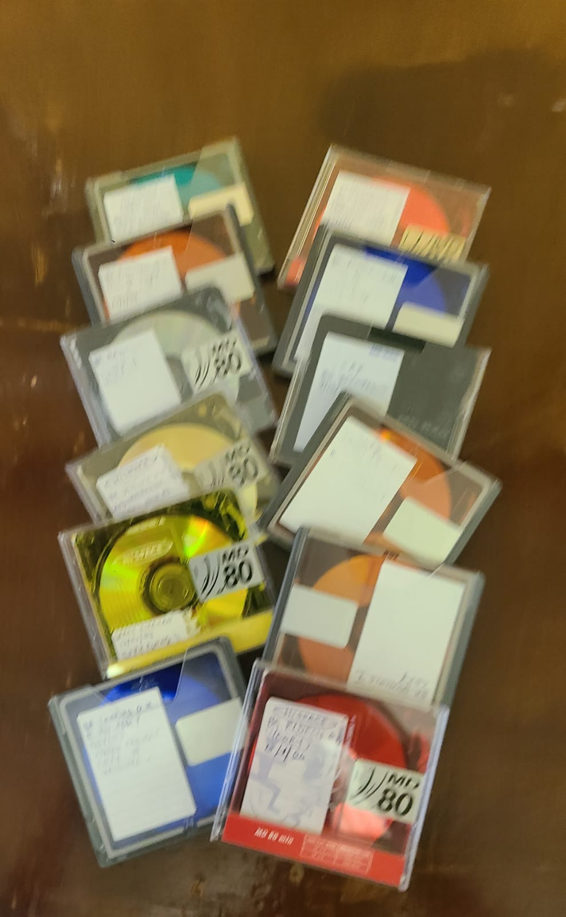
Explore Your Archive is an initiative to bring archival documents and their history to the public. For nine days, items are presented, with a different theme used each day, from the archives of the West European Province of the Saint John of God Brothers. Today's theme is digital, as shown above.

