Explore Your Archive - 3 December 2025
5/9 #EYAPets
Dog and Mouse Chase
For today's theme of pets, we have a series of ink sketches on tracing paper in our archives. While it is not known if the little scenes were copied from somewhere else, or who did the sketching, they tell a delightful and entertaining story, not of a cat and a mouse, but of a dog and mouse chase! The snoozing dog likely awakens when hearing the squeak of the mouse, and unsuccessfully tries to locate it, despite putting in a lot of effort.
The pictures show a great familiarity with the mannerisms and movements of these two types of animal, in how they have been rendered on paper, from the positioning of the dog ears to the ripping up of the bed and the scurrying of the mouse.
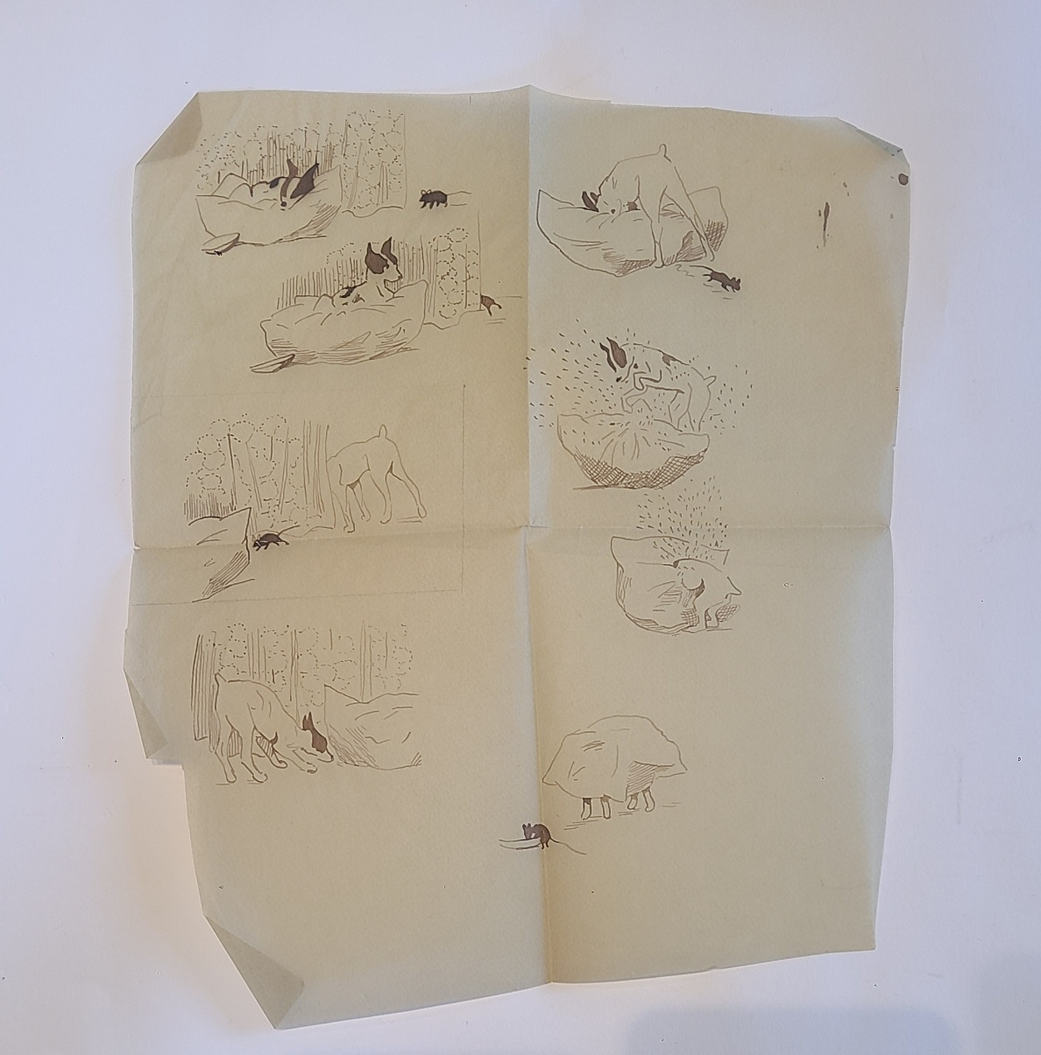
Explore Your Archive is an initiative to bring archival documents and their history to the public. For nine days, items are presented, with a different theme used each day, from the archives of the West European Province of the Saint John of God Brothers. Today's theme is pets, as shown above.



