Explore Your Archive - 2 December 2025
4/9 #EYASilence
Silence at Meals
Brother Finbarr Murphy OH, as Prior of the Saint Joseph's community in Kilcroney, County Wicklow, used a notebook to type up the text of talks for a Chapter of Faults between November 1967 and May 1968. One of the themes he covered was 'Silence'.
At a time when the Saint John of God Order was a lot more monastic in the daily life of its members, Brother Finbarr was expressing frustration at the Rule of Silence not being sufficiently adhered to over mealtimes: "Time and again we have brought to notice the continued violation of the rule of silence, especially in the refectory." Mealtimes mentioned in this regard are breakfast and "first tables". The latter relates to the Brothers who ate early, before everybody else, so that they were free to serve the meal to the rest of the community at table.
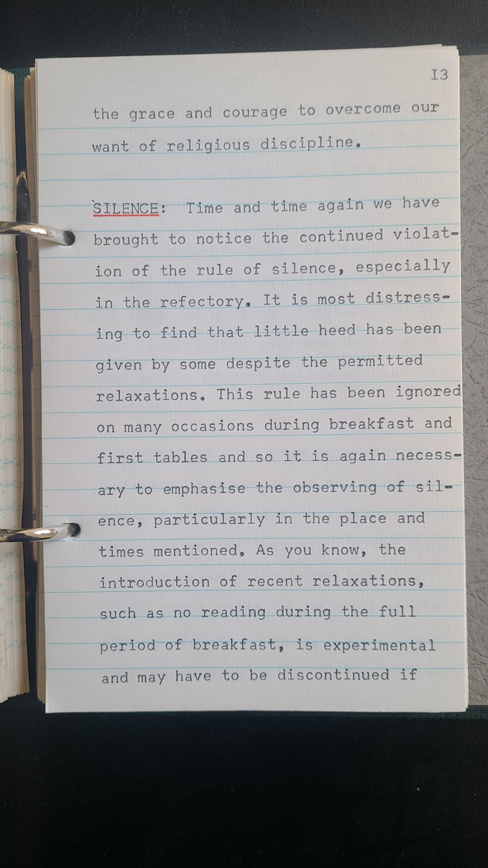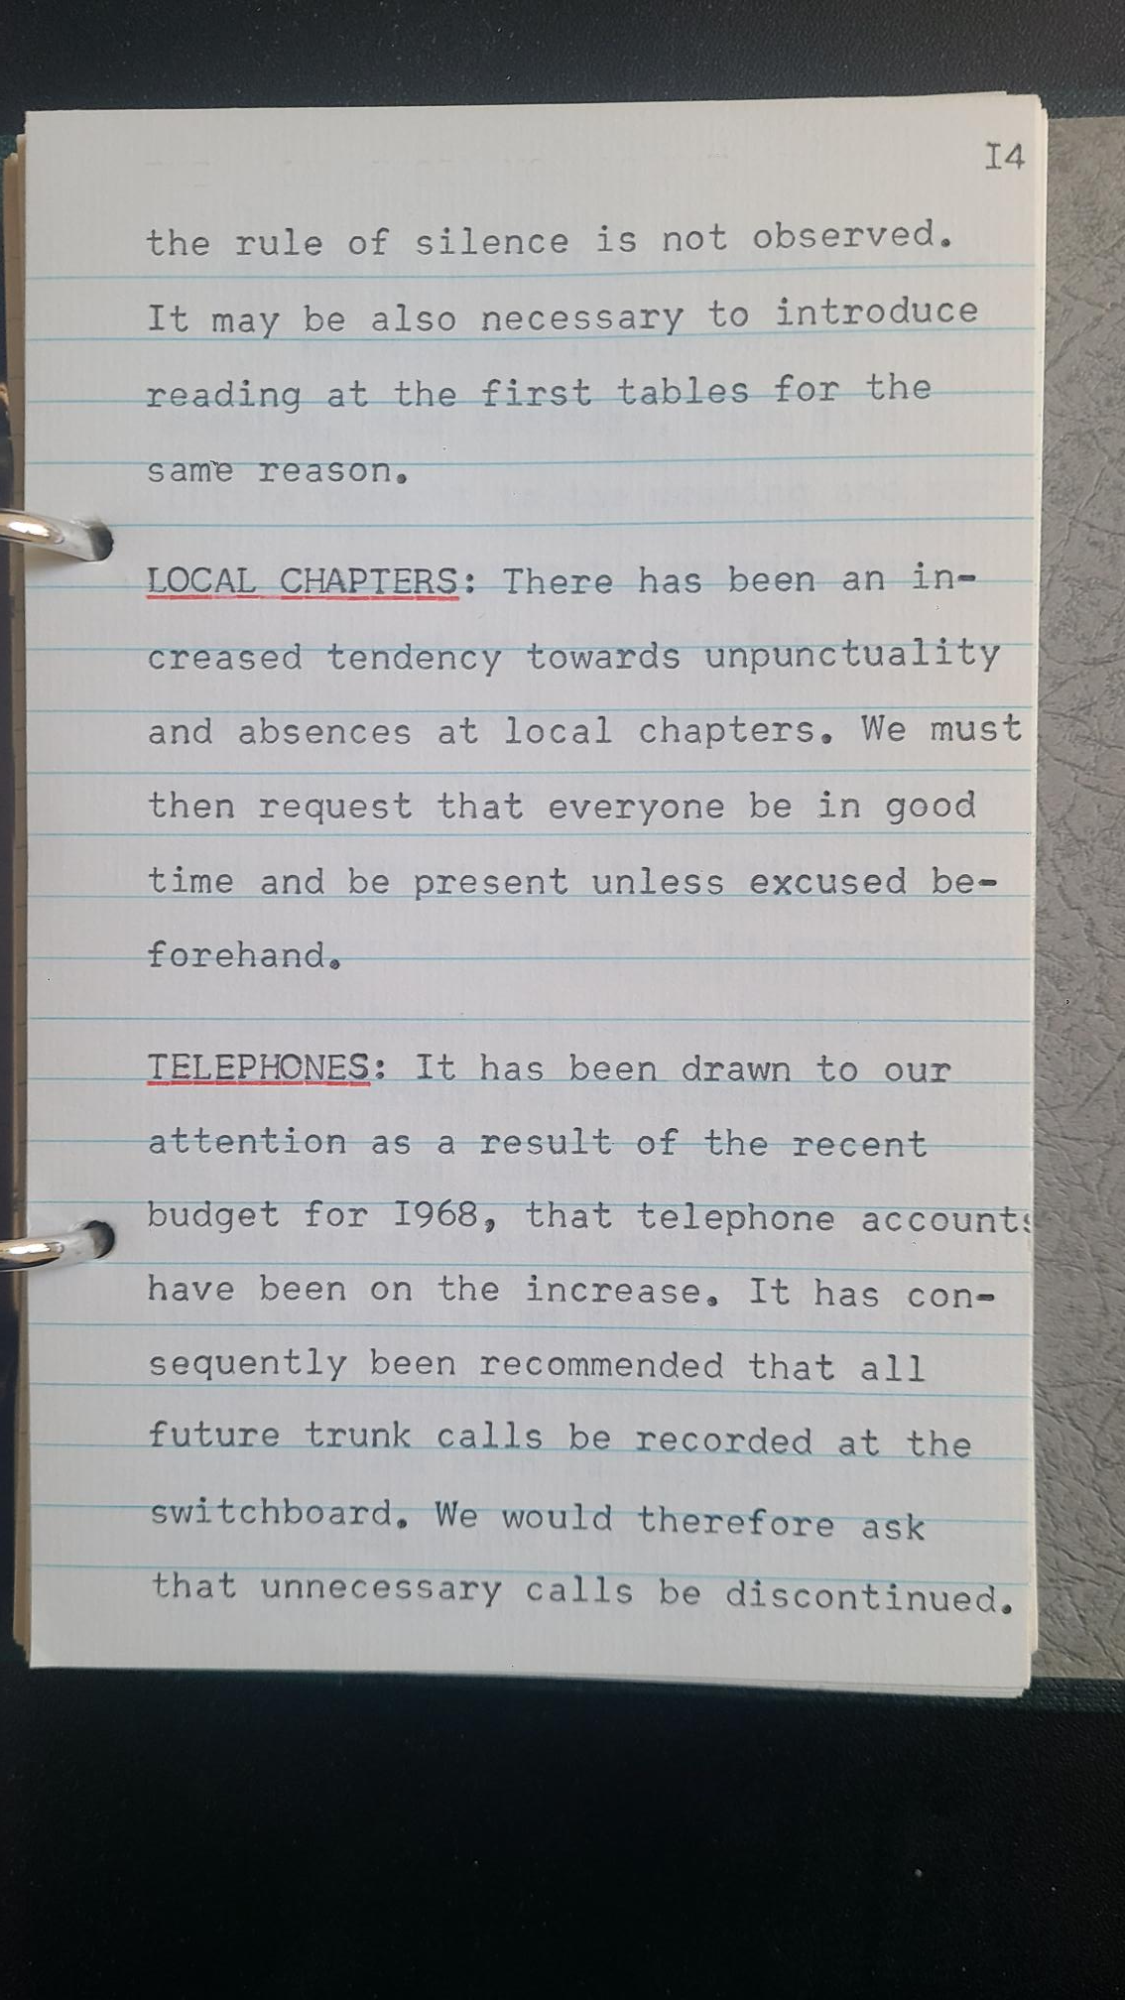
Explore Your Archive is an initiative to bring archival documents and their history to the public. For nine days, items are presented, with a different theme used each day, from the archives of the West European Province of the Saint John of God Brothers. Today's theme is silence, as shown above.



