Explore Your Archive - 1 December 2025
3/9 #EYAMedieval
Saint Roch Stained Glass Window
The Hospitaller Order of Saint John of God was founded in the sixteenth century, but the windows of their chapel in Stillorgan depict several medieval saints associated with healing and caring. Saint Roch, c. 1348 - 1376, is a patron saint of invalids. He was a nobleman who gave up his wealth and tended to the sick during a plague epidemic. Falling ill himself, he was in turn cared for by a dog who brought him food and healed his wounds. His protection was sought during the outbreaks of the Black Plague. This image, commissioned in 1913 from Earley and Co., Dublin, depicts Saint Roch carrying a pilgrim staff, accompanied by his dog.
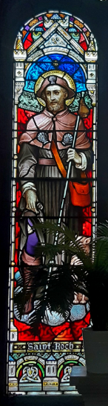
Explore Your Archive is an initiative to bring archival documents and their history to the public. For nine days, items are presented, with a different theme used each day, from the archives of the West European Province of the Saint John of God Brothers. Today's theme is medieval, as shown above.



