Explore Your Archive - 30 November 2025
2/9 #EYABeauty
Leaf Painting
Here we can see a painting, not on a page of paper, but on a leaf! It was made by an unnamed Indian Saint John of God Brother, and survives in perfect condition - both the painted image and the organic material of the leaf.
The leaf is from a peepal tree, which has the botanical name of ficus religiosa, and is the type of tree under which the Buddha is said to have been sitting when he achieved enlightenment. Painting on peepal leaves is a very old form of Indian art, often showing motifs from Hindu mythology or nature.
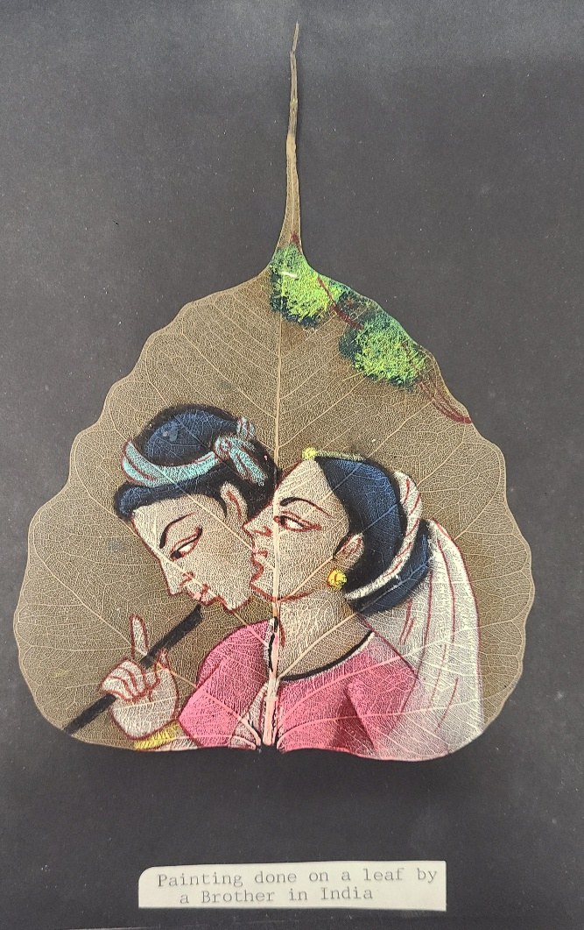

Explore Your Archive is an initiative to bring archival documents and their history to the public. For nine days, items are presented, with a different theme used each day, from the archives of the West European Province of the Saint John of God Brothers. Today's theme is beauty, as shown above.



