Explore Your Archive - 29 November 2025
1/9 #EYAConservation
Conservation Challenges
Here you can see a few pages of a Chapter Book [containing a record of community minutes] of Hurworth Place, a community of the Hospitaller Order of Saint John of God in North Yorkshire, UK. Most entries in this ledger are directly written in manuscript, but several loose typewritten documents have been affixed using glue or, in some cases, cellophane adhesive tape. As the tape degrades the documents come loose, with a risk of becoming damaged or lost, while the tape leaves discoloured adhesive which can bleed through the paper leaves onto the reverse of the pages. One asks how this composite document might best be preserved, and potentially conserved, for consultation by researchers. Professional paper conservation can play a role in cases such as this.
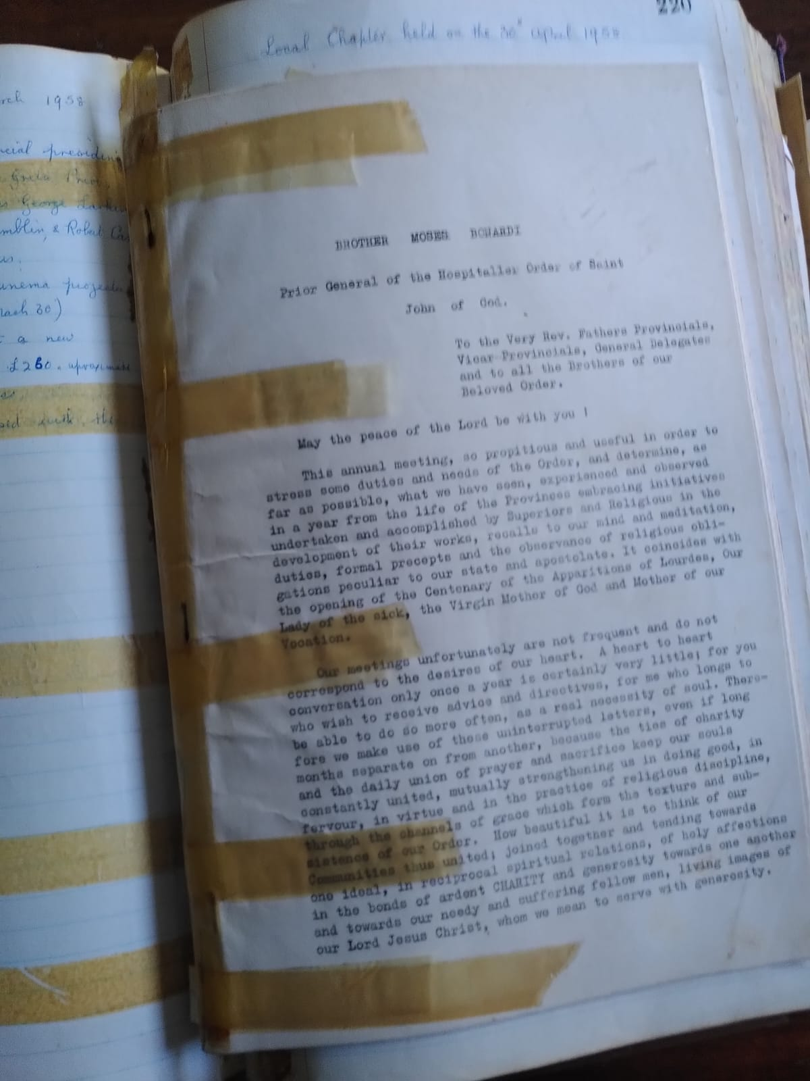
Yellow discoloration across the text

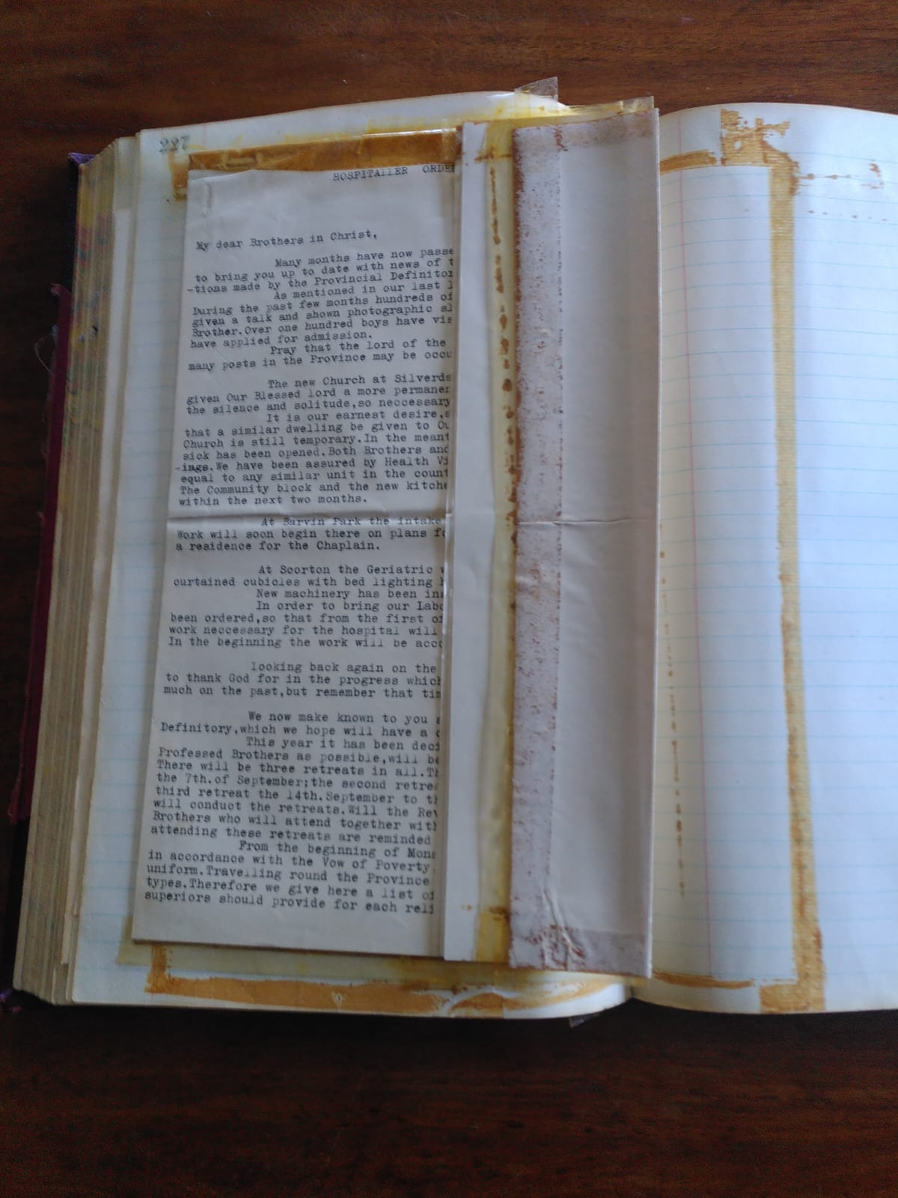
Discoloration and peeling of tape, allowing documents to come loose

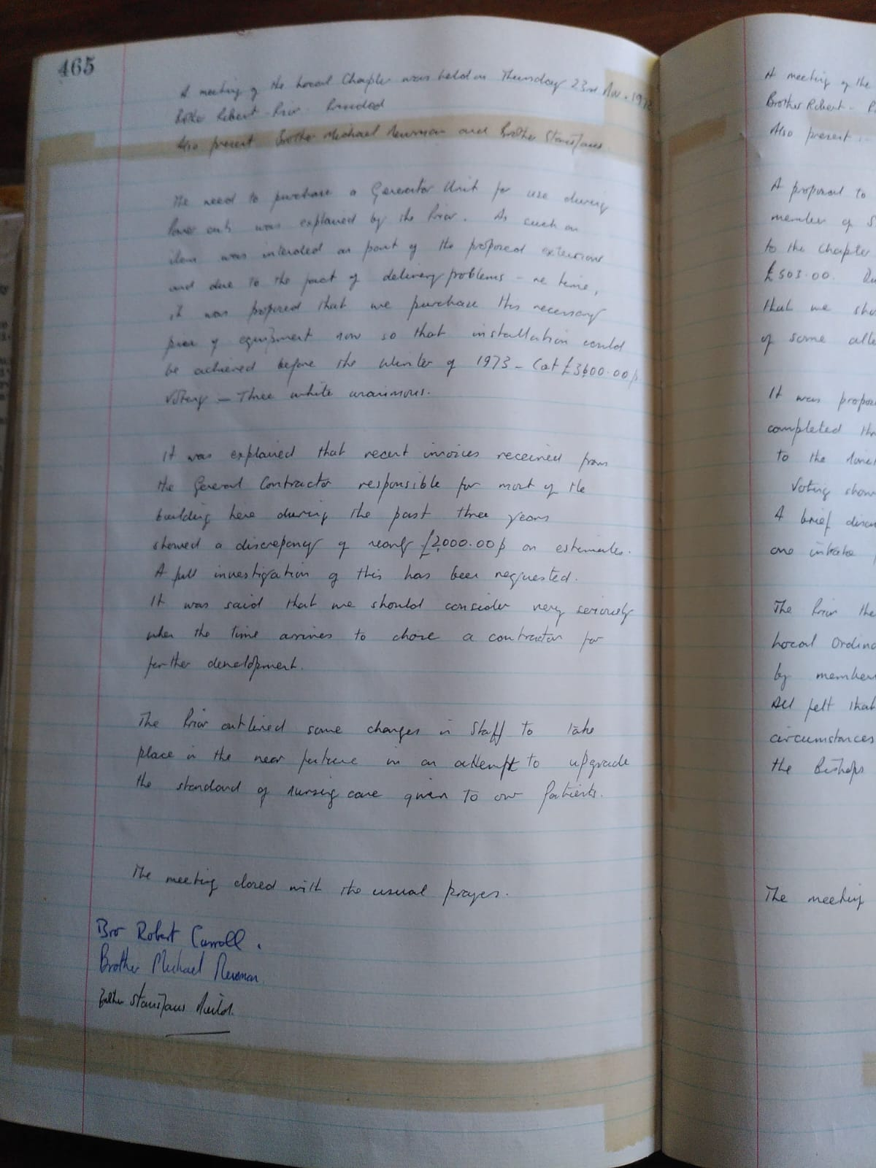
Bleeding through of discoloration onto the reverse page

Explore Your Archive is an initiative to bring archival documents and their history to the public. For nine days, items are presented, with a different theme used each day, from the archives of the West European Province of the Saint John of God Brothers. Today's theme is conservation, as shown above.

